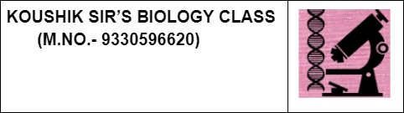

GUIDELINES

(By Subrata Sir & group of ICSE and CBSE school teachers)

Sub-BIOLOGY Class-X (ICSE) Date- 27.12.23 (A/Y-22-23)

TEST-3

F. M.- 80 Time - 2 hrs

# General Instructions:

**1. Answers to this paper must be written on the paper provided separately. 2. You will not be allowed to write during the first 15 minutes.**

# This time is to be spent reading the question paper.

**3. The time given at the head of the paper is the time allotted for writing the answers. 4. Attempt all questions from Section I and any four questions from Section II.**

# 5. The intended marks for questions or parts of questions are given in brackets [ ]. 6. This question paper consists of 5 pages

Section- I (40 Marks)

# Attempt all questions from this section.

Q.1

Select the correct answers to the questions from the given options. (Do not copy the

question, Write the correct answer only.) [15]

1. The outermost layer of meninges:

(a) Pia Mater (b) Arachnoid layer (c) Grey matter (d) Dura mater

1. Loop of Henle lies in:

(a) Medulla (b) Cortex (c) Pelvis (d) Ureter

1. The pigment that gives colour to urine:

(a) Haemoglobin (b) Chlorophyll (c) Urochrome (d) Melanin

1. The number of spinal nerves in humans:

(a) 12 pairs (b) 23 pairs (c) 31 pairs (d) 10 pairs

1. Histamine is produced by-

a. Eosinophil b. Basophil C. Neutrophil d. Lymphocyte

1. (i) After mitotic cell division, a female human cell will have:

(a) 44 + XX chromosomes (b)44 + XY Chromosome (c) 22 + X chromosomes (d)22 + Y chromosome (ii) The number of daughter

1. Fertilisation of the human egg usually occurs in the

a. Vagina b.Uterus c. Fallopian tube d. Cervix

1. Which one of the following is non-biodegradable?

(a) DDT (b) Vegetable peel (c) Cardboard (d) Bark of trees

1. The prime source of chlorofluorocarbon is:

(a) Vehicular emission (b) Industrial effluents (c) Domestic sewage (d) Refrigeration equipments

1. Wooden doors swell up during the rainy season due to

(a) Osmosis (b) Diffusion (c) Imbibition (d) Transpiration

1. 10. The centromere divides into two in:

(a) Prophase (b) Metaphase (c) Anaphase (d) Telophase

1. 1. Which one of the following is the route that a sperm follows when it leaves the testes of a mammal?
2. Vas deferens → epididymis → urethra
3. Urethra → epididymis → vas deferens
4. Epididymis → urethra → vas deferens
5. Epididymis → Vas deferens → urethra
6. On which day of the menstrual cycle does ovulation take place ?

(a) 5th day (b) 28th day (c) 14th day (d) 1st day

1. 4. Ozone is abundant in this layer. Ozone heats this layer as it absorbs incoming ultraviolet radiation from the sun:

(a) Thermosphere (b) Troposphere (c) Mesosphere (d) Stratosphere

1. Which one of the following would not be a limiting factor for photosynthesis?

(a) Oxygen (b) Light (c) Carbon dioxide (d) Chlorophyll*

Q.2

1. Name the following: [5]
2. The fully developed part of the ovary containing a mature egg’
3. The process responsible for variation. (iii) Chemical bond which joins the complementary nitrogenous bases.
4. The plant in which stomata are totally absent.
5. The only gaseous hormone in the plant system.
6. Arrange and rewrite the terms in each group in the correct order so as to be in a logical sequence [5]
7. Fibrin, Platelets, Thromboplastin, Fibrinogen, Thrombin.
8. Synapse, axon ending, cyton, node of Ranvier, dendrite
9. Posterior vena cava, renal artery, aorta, renal vein, kidney
10. Pinna, cochlea, tympanum, ossicles, auditory canal
11. Pupil, yellow spot, cornea, lens, aqueous humour
12. Match the items given in column I with the most appropriate one in column II and rewrite the correct matching pairs. [5]

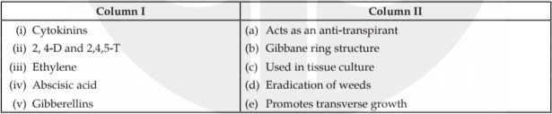

1. Mark the odd one out and write the category to which the others belong for the following questions: [5]
2. Glucose, Amino acids, Urea, Na+
3. Myopia, Hypermetropia, Xerophthalmia, Astigmatism.
4. Semicircular canals, Cochlea, Tympanum, Utriculus.
5. Growth hormone, TSH, Vasopressin, LH.
6. Fallopian tube, Uterus, Ovaries, Ureter
7. State the exact location of the following: [5]
8. Sino-auricular node
9. Hydathodes
10. Hepatic portal vein
11. Eustachian tube
12. Prostate gland

SECTION B

# Attempt any four questions from this section

Q.3

1. Write two differences between karyokinesis and cytokinesis on the basis of occurrence.[2]
2. Briefly explain the term gene.[1]
3. Hormones are called ‘chemical messengers’.Explain [2] (iv).State the significance of meiosis (any 2 points). [2]

(v) Draw neat and labelled diagram of the Malpighian Capsule.[3]

Q. 4

1. Give a biological explanation for : “Plants growing in fertilized soil are often found to wilt if the soil is not adequately watered”. [1]
2. State two functions of Cerebellum.[2]
3. Give one difference between the following pair on the basis of what is given in the bracket: Demography and population density (definition) [2]
4. Give some adaptations in a green leaf for photosynthesis [2]
5. The diagram given below represents an endocrine gland in the human body. Study the diagram and answer the following questions:[3]

|  |  |
| --- | --- |
|  | a. Name the endocrine gland shown in the diagram. |
| b. (ii) Name the secretion of the gland which regulates basal metabolism. |
| c. (iii) Name the mineral element required for the synthesis of the above mentioned hormone. |

Q.5

1. State the difference between Plasmolysis and deplasmolysis.[1]
2. Define double circulation.[2]
3. The blood can not clot inside the blood vessels. Explain [2]
4. Differentiate between the following - Rods and cones . [2]
5. 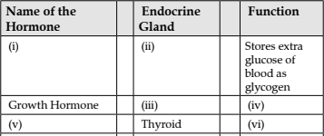Complete the table [3]

Q.6

In Mendel’s experiments, tall pea plants (T) are dominant over dwarf pea plants (t).

1. What is the phenotype and genotype of the F1 generation if a homozygous tall plant is crossed with a homozygous dwarf plant? [1]
2. Draw a Punnett square board to show the gametes and offspring when both the parents are heterozygous for tallness. What is the phenotypic ratio and genotypic ratio of the above cross in (ii)? [3]
3. State Mendel’s Law of Dominance.[2]
4. Differences between Animal and plant cell Mitosis and Mitosis in Animal cell [2]
5. Write the name of the four nitrogen bases in a DNA molecule.[2]

Q.7

1. Give the biological/technical term for the following: The permanent stoppage of menstruation at about the age of 45 years in a female.[1]
2. Write the name of different cells present in testes [2]
3. State the main functions of Placenta. [2] (iv)Twins may or may not be identical. Explain. [2]

(v) Study the diagram given alongside and answer the questions that follows: [3]

|  |  |
| --- | --- |
|  | (a) Name the part labelled A. Name any two hormones produced by the labelled part A. |
| (b) What happens to the part labelled B: If fertilization takes place and If fertilization does not take place. |
| (c) (v) Mention the surgical methods of contraception in: 1. Human males. 2. Human females. |
|  |

Q.8

Study the diagram and answer the following questions:

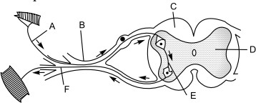

1. Name the pathway that is being depicted and the name of the phenomenon which occurs through this pathway..[2]
2. Name the parts A, B, C and D. [2]
3. Write the name and functions of parts E and F. [2]
4. How does the arrangement of neurons in the spinal cord differ from that of the brain?[1]
5. During a street fight between two individuals, mention the effects on the following organs by the autonomic nervous system, in the table given below .[3]

|  |  |  |
| --- | --- | --- |
| Organs | Sympathetic Nervous System | Parasympathetic Nervous System |
| Lungs |  |  |
| Pupil of the eye |  |  |
| Salivary gland |  |  |